Gurmilan Sangha

2/5/2021

COSC 412

Individual Term Project

My Idea for my Induvial Term Project is to make a website for my Gurdwara. A Gurdwara is a Sikh temple, that is open people from all walks of life. A Gurdwara has a lot to offer in terms of community service, a Gurdwara will always offer free food (Langar), clothing, shelter, and many other services. I have volunteered at my local Gurdwara for almost 10 years. I was a part of the team that installed the security system, serve Langar on a weekly basis and help in other ways like translating for elders. I have always wondered why more people don’t at least come for free food or maybe come other services that are offered. The only reason that comes to mind is knowledge or maybe fear of the unknown. I think a website that people in the surrounding area could use to learn more about what the Gurdwara has to offer would benefit everyone involved. Also, the website could be used to share pictures from recent festivals, share important information in the community and allow the Gurdwara to come send important information about closings to each user by email.

So, to clearly state, I the Gurdwara’s website would be used by people in Dundalk and the surround areas to learn more about Siki and Sikhs and to be able reach out for help if they need. I also think people who attend the Gurdwara weekly would use the website for news, pictures, and other important info. I have seen bigger Gurdwaras have websites, that basically do all the function mentioned. I would like to follow the format of The San Jose Gurdwara.

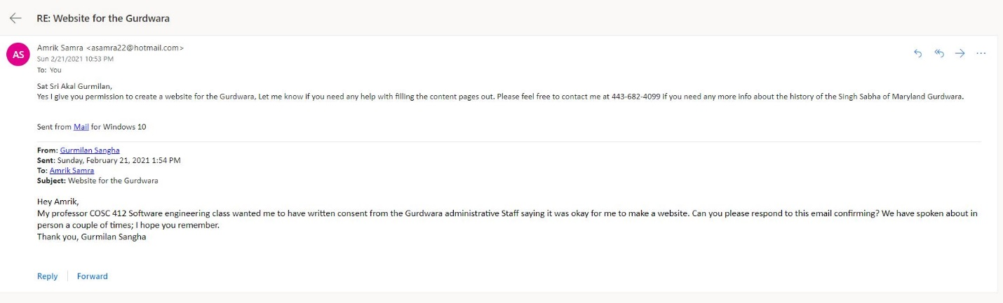

Work Cited

“Sikh Gurdwara Sahib - San Jose.” *Sikh Gurdwara Sahib - San Jose, CA (Official Website)*, sanjosegurdwara.org/.